

ade lab simulation

Asynchronous Up Counter Simulation



BY:

MoHAMMED YAHYA

USN: 3PD23CS076

SAINATH PATIL

USN: 3PD23CS120

SEC: B

**Asynchronous Up Counter**

**Aim:** To display 3 bit binary digits from 0 to 7 using asynchronous up counter.

**Theory**: 3 bit asynchronous counter can be made by using sequential circuit of 3 T flip-flop. Then 3-bit binary number can be displayed by 7-segment display using BCD decoder.

**Circuit Diagram:**

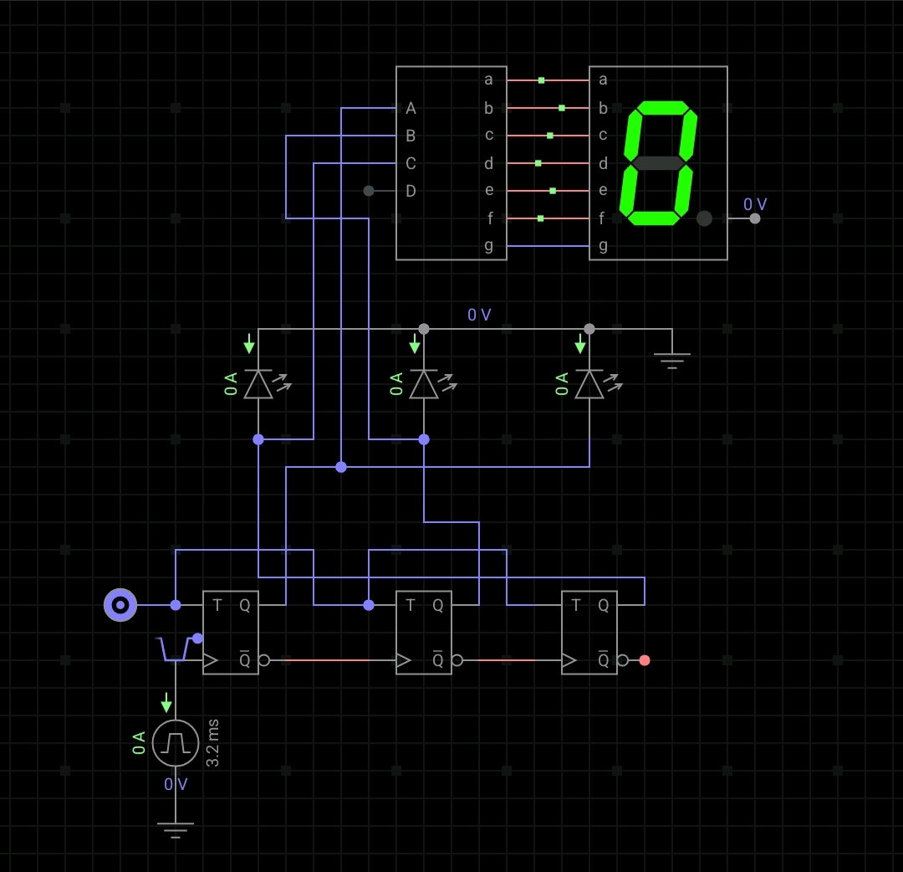

**Truth Table**:

Asynchronous counter:

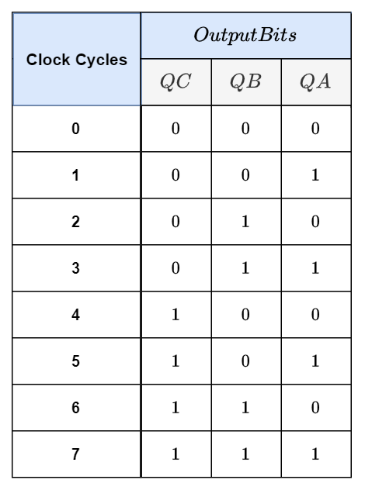

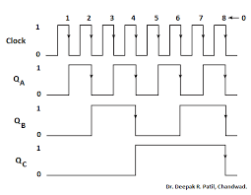

The binary output from the 3 bit asynchronous counter is given as input to BCD converter and it is displayed by 7 segment display as shown

**BCD to 7 segment decoder**:

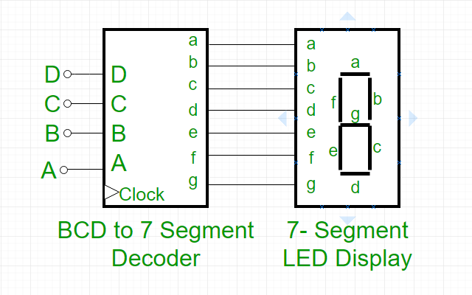

**Final output**:

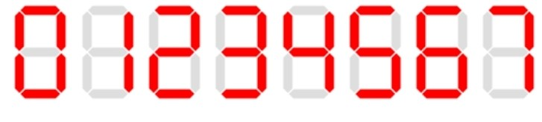

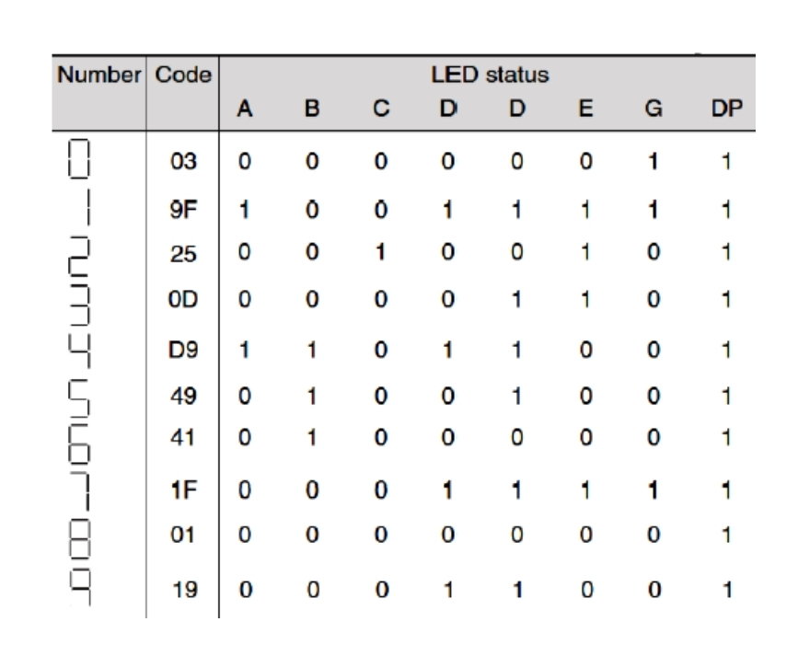

**Thank You** for your understanding.